Part I

1a) It gives an info on man command.

“man - an interface to the on-line reference manuals” .  
Info is similar to man, with a more robust structure for linking pages together. Info pages are made using the texinfo tools, and can link with other pages, create menus and ease navigation in general.

They can be used separately as such

info [OPTION]... [MENU-ITEM...]

man [option(s)] keyword(s)

1b) Shows listing of the most recently logged in users.

1c) Just shows the output of the command of last.   
 I think what professor wants is last hasnain – (where Hasnain is the value of whoami, but last doesn’t support piping)

1d) lsblk - list block devices. It’s the partitions of hard drive.

NAME MAJ:MIN RM SIZE RO TYPE MOUNTPOINT

sda 8:0 0 20G 0 disk

├─sda1 8:1 0 19G 0 part /

├─sda2 8:2 0 1K 0 part

└─sda5 8:5 0 1022M 0 part [SWAP]

sr0 11:0 1 647M 0 rom

1e) free - Display amount of free and used memory in the system

total used free shared buff/cache available

Mem: 1001592 255996 295632 7904 449964 593028

Swap: 1046524 0 1046524

1f) finger me, gives an error because “me” isn’t a user.

: me: no such user.

finger Hasnain gives valid result

Login: hasnain Name: hasnain attarwala

Directory: /home/hasnain Shell: /bin/bash

On since Mon Feb 12 15:03 (CST) on tty7 from :0

34 minutes 10 seconds idle

No mail.

No Plan.

2 a) Generate a hard password of a specified length

“gpw 1 7” – where we are creating 1 password of 7 length

“gpw 5 3” – where we are creating 5 passwords of 3 length

2 b) Show how much space is used on the hard drive.

“dp” - reports file system disk space usage

2 c) See who is currently logged on the system

“w” – shows who all is currently logged in.

3) 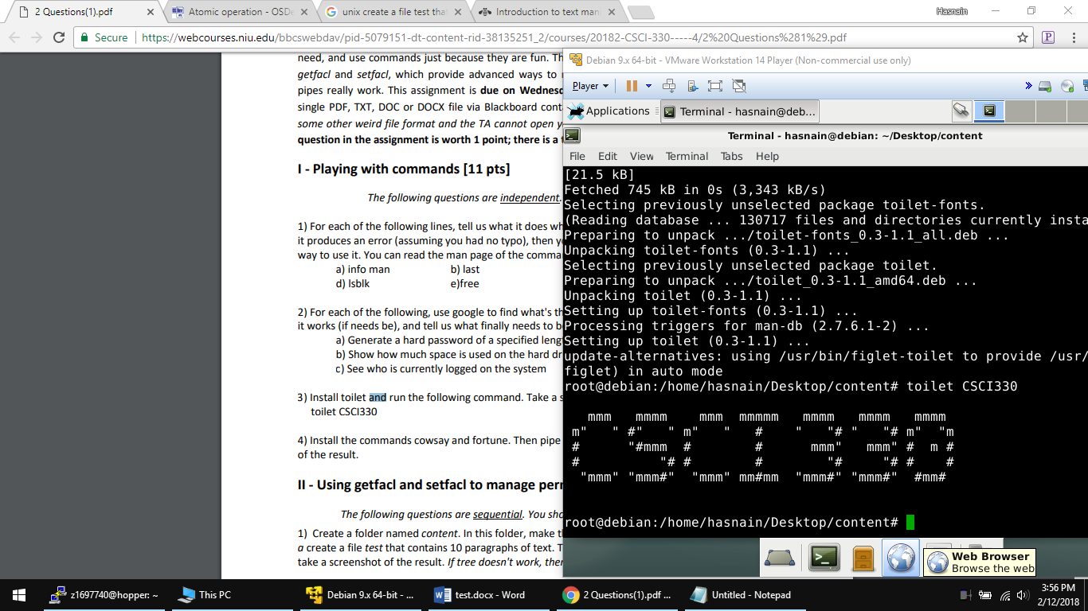

4) 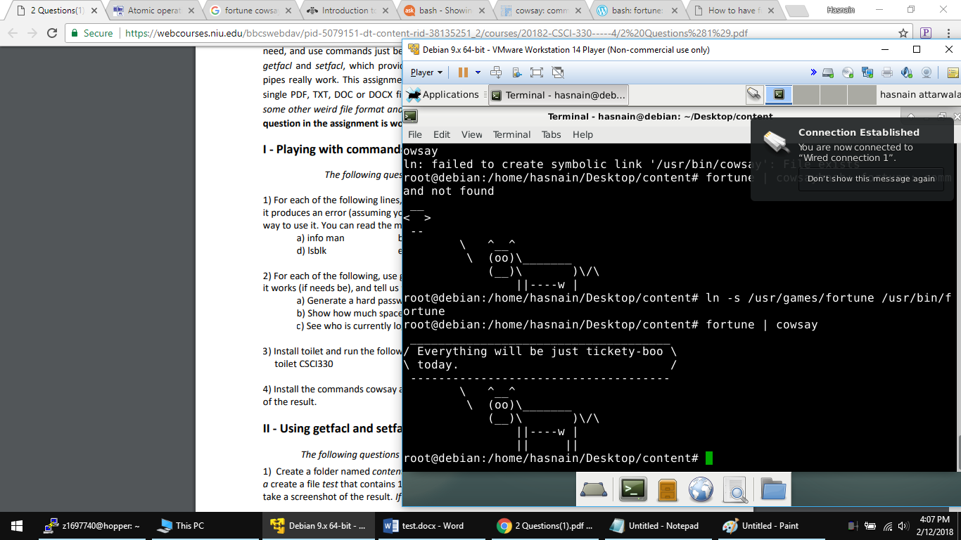

Part II

1) 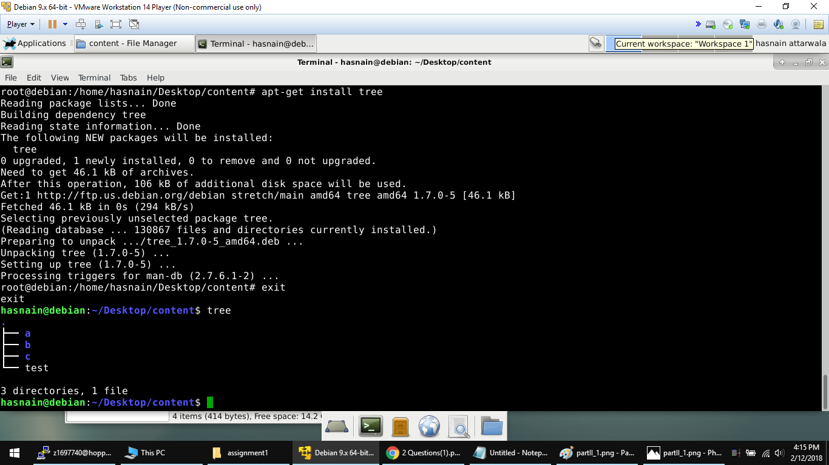

2) # file: test – name of file

# owner: Hasnain – who the owner is

# group: Hasnain – who the group it belongs to

user::rw- – what permissions user has

group::r-- – what permissions the group has

other::r— – what permissions other’s have

3) # file: c

# owner: hasnain

# group: hasnain

user::rwx

group::r-x

other::r-x

default:user::rwx

default:group::r-x

default:other::rwx

we see the default values of all UGO. When we do getfacl c the default (-d) has been modified (-m) of other’s to rwx (o::rwx).

4) Because of earlier command “setfacl -d -m o::rwx c”. When we created subC1 directory. It’s Other permissions were set to rwx. While subA1 remained the same/default.

*getfacl /home/hasnain/Desktop/content/c/subC1*

*getfacl: Removing leading '/' from absolute path names*

*# file: home/hasnain/Desktop/content/c/subC1*

*# owner: hasnain*

*# group: hasnain*

*user::rwx*

*group::r-x*

*other::rwx*

*default:user::rwx*

*default:group::r-x*

*default:other::rwx*

*getfacl /home/hasnain/Desktop/content/a/subA1*

*getfacl: Removing leading '/' from absolute path names*

*# file: home/hasnain/Desktop/content/a/subA1*

*# owner: hasnain*

*# group: hasnain*

*user::rwx*

*group::r-x*

*other::r-x*

5) The default permissions of dir c (others having rwx, different from original/default) got copied into dir a, but not it’s sub directory’s

# file: a

# owner: hasnain

# group: hasnain

user::rwx

group::r-x

other::r-x

default:user::rwx

default:group::r-x

default:other::rwx

# file: a/subA1

# owner: hasnain

# group: hasnain

user::rwx

group::r-x

other::r-x

Part III

1. Really really long time. Started at 1:15pm ended at 1:21pm so about 6 minutes.
2. 1 second for each “hello world”

3a) 4096 and screenshot of 512*8 highlighted.

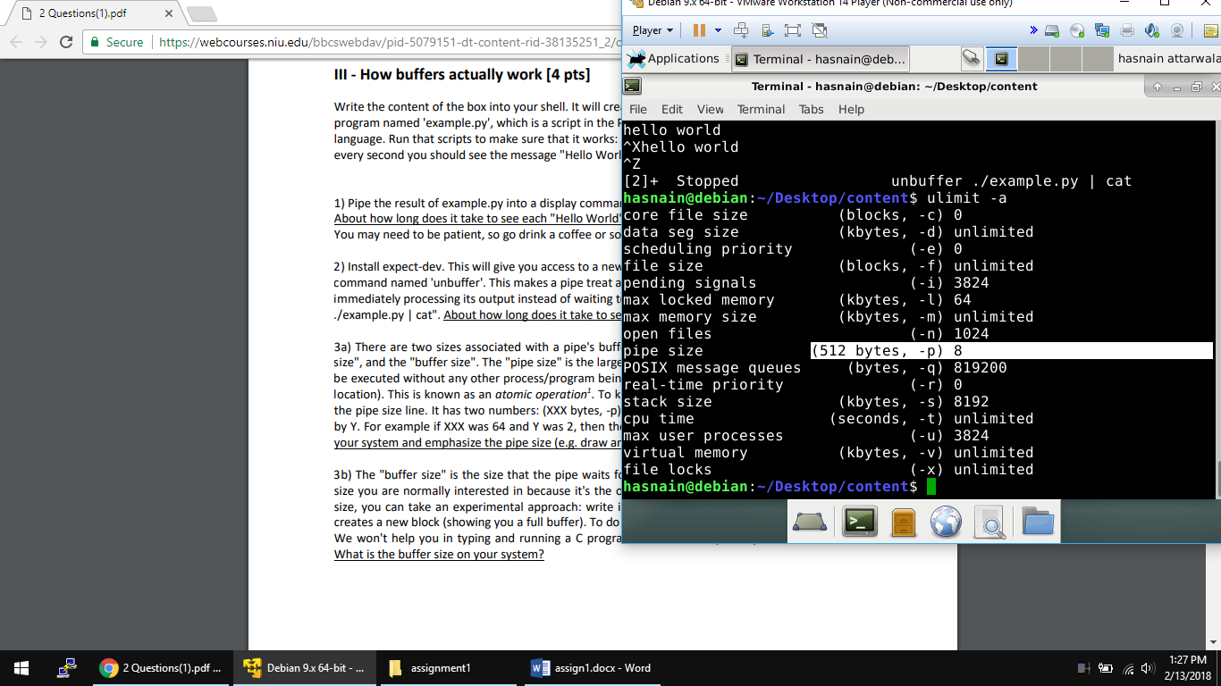

3b) 65537 bytes.